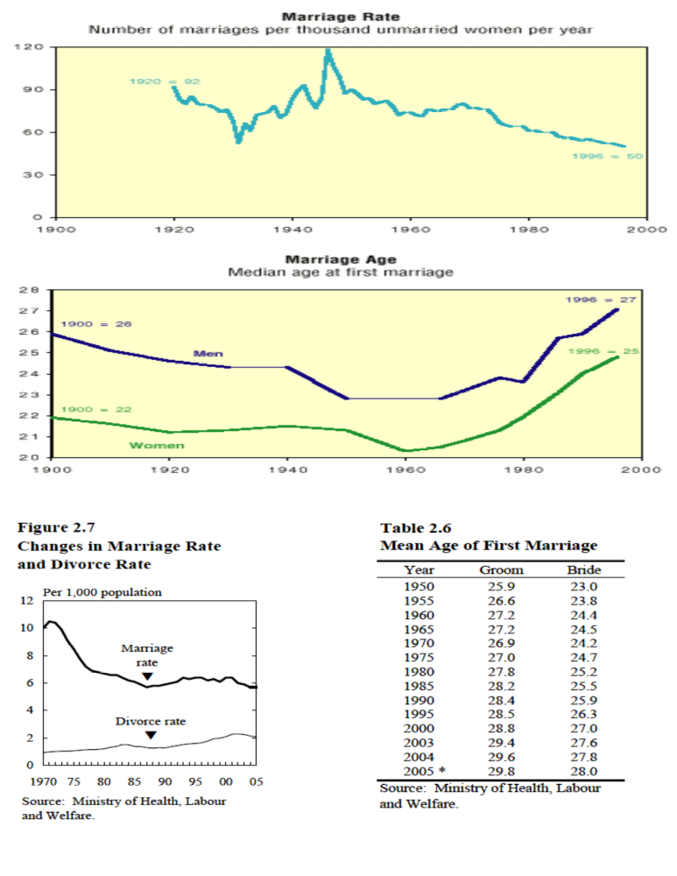
Sources:
http://www.pbs.org/fmc/book/4family1.htm
http://www.stat.go.jp/English/data/handbook/c02cont.htm
http://www.unmarried.org
http://www.wikipedia.org
Sources:
http://www.pbs.org/fmc/book/4family1.htm
http://www.stat.go.jp/English/data/handbook/c02cont.htm
http://www.unmarried.org
http://www.wikipedia.org
Sources:
http://www.pbs.org/fmc/book/4family1.htm
http://www.stat.go.jp/English/data/handbook/c02cont.htm
http://www.unmarried.org
http://www.wikipedia.org
Sources:
http://www.pbs.org/fmc/book/4family1.htm
http://www.stat.go.jp/English/data/handbook/c02cont.htm
http://www.unmarried.org
http://www.wikipedia.org
Sources:
http://www.pbs.org/fmc/book/4family1.htm
http://www.stat.go.jp/English/data/handbook/c02cont.htm
http://www.unmarried.org
http://www.wikipedia.org
Sources:
http://www.pbs.org/fmc/book/4family1.htm
http://www.stat.go.jp/English/data/handbook/c02cont.htm
http://www.unmarried.org
http://www.wikipedia.org
Sources:
http://www.pbs.org/fmc/book/4family1.htm
http://www.stat.go.jp/English/data/handbook/c02cont.htm
http://www.unmarried.org
http://www.wikipedia.org
Sources:
http://www.pbs.org/fmc/book/4family1.htm
http://www.stat.go.jp/English/data/handbook/c02cont.htm
http://www.unmarried.org
http://www.wikipedia.org
Sources:
http://www.pbs.org/fmc/book/4family1.htm
http://www.stat.go.jp/English/data/handbook/c02cont.htm
http://www.unmarried.org
http://www.wikipedia.org
Sources:
http://www.pbs.org/fmc/book/4family1.htm
http://www.stat.go.jp/English/data/handbook/c02cont.htm
http://www.unmarried.org
http://www.wikipedia.org
Sources:
http://www.pbs.org/fmc/book/4family1.htm
http://www.stat.go.jp/English/data/handbook/c02cont.htm
http://www.unmarried.org
http://www.wikipedia.org
Sources:
http://www.pbs.org/fmc/book/4family1.htm
http://www.stat.go.jp/English/data/handbook/c02cont.htm
http://www.unmarried.org
http://www.wikipedia.org
Sources:
http://www.pbs.org/fmc/book/4family1.htm
http://www.stat.go.jp/English/data/handbook/c02cont.htm
http://www.unmarried.org
http://www.wikipedia.org
Sources:
http://www.pbs.org/fmc/book/4family1.htm
http://www.stat.go.jp/English/data/handbook/c02cont.htm
http://www.unmarried.org
http://www.wikipedia.org
Sources:
http://www.pbs.org/fmc/book/4family1.htm
http://www.stat.go.jp/English/data/handbook/c02cont.htm
http://www.unmarried.org
http://www.wikipedia.org
Sources:
http://www.pbs.org/fmc/book/4family1.htm
http://www.stat.go.jp/English/data/handbook/c02cont.htm
http://www.unmarried.org
http://www.wikipedia.org
Sources:
http://www.pbs.org/fmc/book/4family1.htm
http://www.stat.go.jp/English/data/handbook/c02cont.htm
http://www.unmarried.org
http://www.wikipedia.org
Sources:
http://www.pbs.org/fmc/book/4family1.htm
http://www.stat.go.jp/English/data/handbook/c02cont.htm
http://www.unmarried.org
http://www.wikipedia.org
Sources:
http://www.pbs.org/fmc/book/4family1.htm
http://www.stat.go.jp/English/data/handbook/c02cont.htm
http://www.unmarried.org
http://www.wikipedia.org
Sources:
http://www.pbs.org/fmc/book/4family1.htm
http://www.stat.go.jp/English/data/handbook/c02cont.htm
http://www.unmarried.org
http://www.wikipedia.org
Sources:
http://www.pbs.org/fmc/book/4family1.htm
http://www.stat.go.jp/English/data/handbook/c02cont.htm
http://www.unmarried.org
http://www.wikipedia.org
Sources:
http://www.pbs.org/fmc/book/4family1.htm
http://www.stat.go.jp/English/data/handbook/c02cont.htm
http://www.unmarried.org
http://www.wikipedia.org
Sources:
http://www.pbs.org/fmc/book/4family1.htm
http://www.stat.go.jp/English/data/handbook/c02cont.htm
http://www.unmarried.org
http://www.wikipedia.org
Sources:
http://www.pbs.org/fmc/book/4family1.htm
http://www.stat.go.jp/English/data/handbook/c02cont.htm
http://www.unmarried.org
http://www.wikipedia.org
Sources:
http://www.pbs.org/fmc/book/4family1.htm
http://www.stat.go.jp/English/data/handbook/c02cont.htm
http://www.unmarried.org
http://www.wikipedia.org
Sources:
http://www.pbs.org/fmc/book/4family1.htm
http://www.stat.go.jp/English/data/handbook/c02cont.htm
http://www.unmarried.org
http://www.wikipedia.org
Sources:
http://www.pbs.org/fmc/book/4family1.htm
http://www.stat.go.jp/English/data/handbook/c02cont.htm
http://www.unmarried.org
http://www.wikipedia.org
Sources:
http://www.pbs.org/fmc/book/4family1.htm
http://www.stat.go.jp/English/data/handbook/c02cont.htm
http://www.unmarried.org
http://www.wikipedia.org
Sources:
http://www.pbs.org/fmc/book/4family1.htm
http://www.stat.go.jp/English/data/handbook/c02cont.htm
http://www.unmarried.org
http://www.wikipedia.org
Sources:
http://www.pbs.org/fmc/book/4family1.htm
http://www.stat.go.jp/English/data/handbook/c02cont.htm
http://www.unmarried.org
http://www.wikipedia.org


